Computer Graphics and Image Processing
CMP513 + CMP514

Project Proposal Template
Cover Page

- Project Title: 3D Space Exploration

- Team Members:

Sr. No. | Enrollment No. | Name
1 | 24000636 | Sampatti Dave
2 | 24000859 | Zels Sorathiya
3 | 24000925 | Hriday Joshi

- Date of Submission:20-07-2026

Contents
1. Project Overview 3
1.1 Project Title 3
1.2 Project Category 3
1.3 Abstract (150–250 words) 3
2. Problem Definition 4
3. Motivation 5
4. Objectives 5
5. Scope of the Project 6
5.1 Included Features 6
5.2 Excluded Features 6
6. Literature Survey 7
7. Proposed Solution 7
8. System Architecture 9
9. Functional Requirements 10
10. Non-Functional Requirements 10
11. Methodology 11
12. Algorithms and Techniques 11
13. Technology Stack 12
14. Dataset 13
15. Expected Deliverables 14
16. Work Breakdown Structure 15
17. Timeline (8–10 Weeks) 16
18. Innovation 16
19. References 18

1. Project Overview

1.1 Project Title
3D Space Exploration

1.2 Project Category
Select the appropriate category

- Computer Graphics
☐ Image Processing
☐ Graphics + Image Processing
☐ GUI Application
☐ Multimedia
☐ AR/VR
- 3D Graphics
☐ Game Development

☐ Other: ______________________________________________________________________
______________________________________________________________________________

1.3 Abstract (150–250 words)
Existing space-simulation software tends to fall into one of two categories: scientifically rigorous tools with limited visual polish, such as Spaceflight Simulator and Kerbal Space Program, or visually accomplished tools designed primarily for data browsing rather than guided learning, such as NASA's Eyes on the Solar System.
This project proposes an interactive 3D space exploration and educational visualization system that combines real-time, visually rich rendering with scientifically grounded orbital motion and contextual, curiosity-driven educational content. Users will be able to freely navigate a curated 3D representation of the Solar System. This includes the Sun, all eight planets, selected moons, and additional deep-space set-piece objects with celestial bodies following simplified two-body Keplerian orbital motion for scientific authenticity. As the user approaches an object, the system triggers a focused camera view and displays curated encyclopedia-style content about that body, rather than requiring the user to consult external resources.
The system will be developed in Unity (C#) using the Universal Render Pipeline for physically based rendering, Shader Graph for custom visual effects such as atmospheric rim-lighting, and Cinemachine for cinematic camera control, within a data-driven architecture designed for extensibility. The expected outcome is a polished, scientifically credible, and pedagogically effective standalone application suitable for educational use.
The software architected so that a future rocket-building and trajec ory-simulation module explicitly out of scope for this phase could be integrated without major redesign.

2. Problem Definition
What problem exists: Current space-simulation and visualization tools force a tradeoff that doesn't need to exist. Tools built around real physics and rocket mechanics (Spaceflight Simulator, Kerbal Space Program) are scientifically credible but visually and presentationally dated or minimal. Tools with strong visual and data credibility (NASA's Eyes on the Solar System) are built for browsing accurate mission data, not for guided, curiosity-driven learning by someone encountering the subject for the first time. No widely available tool currently combines high production-value 3D rendering with real orbital science and an interface designed around teaching rather than data lookup.
Who experiences this problem: Students and self-directed learners with an interest in astronomy or spaceflight who want an engaging way to explore the subject without either being dropped into a mission-tracking tool built for domain-literate users, or settling for visually flat software that fails to hold attention; also relevant to educators seeking a classroom-usable visualization aid.
Why it is important: Spaceflight and astronomy are high-interest, motivating entry points into STEM subjects generally, and this is particularly relevant in the current Indian context given the growing visibility of ISRO's missions and rising public interest in space exploration. A genuinely engaging, visually strong educational tool lowers the barrier to self-directed learning in this domain more effectively than either a dry simulation or a data browser built for specialists.
Limitations of current approaches:
- Spaceflight Simulator (SFS): genuinely simplified but physically grounded orbital mechanics, but presentation is entirely 2D, limiting spatial understanding and visual engagement, and offers no in-context education users learn by trial and error or they may end up leaving the app.
- Spaceflight Simulator 2 (announced sequel): a full 3D rebuild with realistic orbital and aerodynamic physics is in active development, but it is oriented toward hardcore rocket-building and simulation depth rather than guided education, and is not yet released.
- Kerbal Space Program 1 and 2: KSP1 remains deep and community-supported but has dated visuals and a notoriously steep learning curve for newcomers; KSP2's development studio was shut down by its publisher and development has not resumed, leaving no actively developed successor in this space.
- Universe Sandbox: offers rich, free-form celestial-scale simulation and exploration, but has no rocket-building component and no narrative or guided-learning structure. It is a sandbox for people who already know what they want to do with it.
- NASA's Eyes on the Solar System: authoritative, accurate, and actively maintained, but designed around mission-tracking and spacecraft data for an informed audience rather than curiosity-led discovery for a newcomer.

3. Motivation
- Why did your team choose this project?
The team's original concept combined a 3D rocket-building and trajectory-simulation system with a free-roam space exploration mode. Through scoping analysis, the team determined that a full rocket assembly and physics-simulation engine. This idea covered thrust, staging, fuel dynamics, drag, and trajectory prediction. This made it too large a scope to deliver to a finished, polished standard within a single semester alongside a full course load, and that the physics-simulation subsystem carried the highest technical risk relative to its centrality to a Computer Graphics evaluation.
The team chose to scope this phase to the 3D exploration and visualization component, which preserves the most visually and technically rich elements of the original concept while remaining achievable to a high standard of polish in the available time. The rocket-building and trajectory system is retained as documented future scope, with the current system's architecture deliberately designed to support that integration later.
- What inspired this idea?
The idea draws on existing space simulation and visualization software which are Spaceflight Simulator, Kerbal Space Program, and NASA's Eyes on the Solar System. The team's shared interest in space exploration and astronomy along with current developments in spaceflight such as ISRO's missions. Also played a major role in deriving this idea
- Why it is useful?
Beyond its educational value, the project functions as a substantive demonstration of real-time 3D graphics techniques physically based rendering, custom shader work, camera systems, and large-scale rendering precision within a single, coherent, purpose-built application, rather than a set of disconnected exercises. It is also structured to grow: the current phase is a complete, self-contained deliverable, and the deferred rocket-building phase gives the project a credible path to expand beyond this course if the team chooses to continue it.

4. Objectives
- Render the Sun, eight planets, and a curated set of moons in real time with physically based materials and scientifically informed relative scale.
- Implement two-body Keplerian orbital motion so that all celestial bodies move along scientifically accurate paths over time.
- Implement free-roam 3D camera navigation allowing unrestricted movement through the environment.
- Implement a floating-origin and level-of-detail (LOD) system to maintain rendering precision and performance across astronomical distances.
- Implement custom shader-based visual effects, including Fresnel-based atmospheric rim-lighting and a real-time starfield/skybox.
- Implement a contextual encyclopedia system that displays curated educational content when the user approaches a celestial object.
- Implement a data-driven content architecture (JSON-based celestial body and encyclopedia definitions) to support future extensibility without code changes for new content.
- Architect core systems : navigation, camera control, and the data layer so that a future rocket-building and trajectory-simulation module can be integrated without a fundamental redesign.

5. Scope of the Project

5.1 Included Features
- Free-roam 3D navigation through a curated space environment
- The Sun, all eight planets, and a curated set of moons, rendered with physically based materials and real or derived texture maps
- Two-body Keplerian orbital motion for all celestial bodies (scientifically accurate relative motion, without full N-body or thrust/gravity simulation)
- Floating-origin and level-of-detail (LOD) systems supporting astronomical-scale distances without rendering artifacts
- Custom shader effects, including Fresnel-based atmospheric rim-lighting and animated starfield/skybox rendering
- A full post-processing pipeline (bloom, color grading/tonemapping, vignette, depth of field)
- Cinematic camera behavior (Cinemachine-driven approach transitions, focus behavior, launch-style camera work)
- A contextual "encyclopedia" information system triggered on approach to a celestial object
- Two or more curated deep-space "set-piece" destinations beyond the Solar System proper (e.g., a stylized black hole, a nebula)
- A data-driven celestial body and content configuration system (JSON-based)

5.2 Excluded Features (Future Scope)
- Rocket assembly / building system (part catalog, staging, part-snapping)
- Full rigid-body, thrust, and drag physics simulation
- Trajectory prediction and maneuver planning
- N-body gravitational simulation
- Procedurally generated, non-curated infinite universe
- Multiplayer, cloud save, or online design-sharing features
- Mobile platform release (this phase targets desktop)
- Image processing components of any kind (this project's category selection is Computer Graphics; no image-processing deliverable is included)

6. Literature Survey
Review 3–5 existing tools or research papers.
Existing Solution | Features | Limitations
Spaceflight Simulator (SFS) | Simplified but genuinely physics-based orbital mechanics; free, with a large mobile and PC player base | Entirely 2D presentation; minimal visual polish; no in-context educational content
Spaceflight Simulator 2 (announced) | Full 3D rebuild of SFS with 120+ parts and realistic orbital and aerodynamic physics, in active development by the original studio | Oriented toward hardcore rocket-building and simulation depth rather than guided education; not yet released
Kerbal Space Program 1 & 2 | KSP1: deep, community-supported, physics-rich; KSP2: intended modernized visuals on the same proven formula | KSP1 has dated visuals and a steep learning curve; KSP2's development studio was shut down by its publisher and development has not resumed
Universe Sandbox | Rich real-time gravity and celestial-scale simulation; free exploration of custom and real systems | No rocket-building component; no guided or narrative educational structure
NASA's Eyes on the Solar System | A 3-D environment built on real NASA mission data, letting users explore the cosmos, follow spacecraft, and see the whole system moving in real time | Designed around mission-tracking and spacecraft data for an informed audience rather than guided discovery for a newcomer; no narrative or teaching-first structure

7. Proposed Solution
Working principle: The system maintains a lightweight kinematic model of the Solar System, in which each celestial body's position is computed at any simulated time directly from its orbital elements using the two-body Kepler equations, rather than through full gravitational integration. This state feeds a rendering layer that presents each body with physically based materials, custom shaders for effects such as atmospheric glow, and a scale-management system that keeps distant and nearby objects rendering correctly in the same scene. A separate interaction layer continuously checks the user's position against each object's proximity threshold; crossing that threshold triggers a cinematic camera transition into a focused view and surfaces that object's curated encyclopedia content, without interrupting the underlying simulation.
Processing steps (per frame / per interaction):
- Compute each celestial body's current position and orientation from its orbital elements for the current simulation time.
- Update the floating-origin reference point relative to the camera to prevent floating-point precision artifacts at large distances.
- Select the appropriate level of detail for each visible object based on camera distance.
- Render the scene: materials, custom shaders (atmosphere, star shimmer), skybox, and the post-processing pipeline.
- Check the user/camera position against each object's proximity trigger.
- On trigger, transition the camera into a focused view of the object and display its encyclopedia panel.
- On exit from the focused view, resume free-roam navigation and hide the panel.
Expected workflow (user journey):
Launch application Main Menu enter Exploration Mode
free-roam navigation through the Solar System approach a celestial object
automatic camera focus and encyclopedia panel appear
continue exploring or return to free-roam optionally visit curated deep-space set-piece destinations exit session.

8. System Architecture

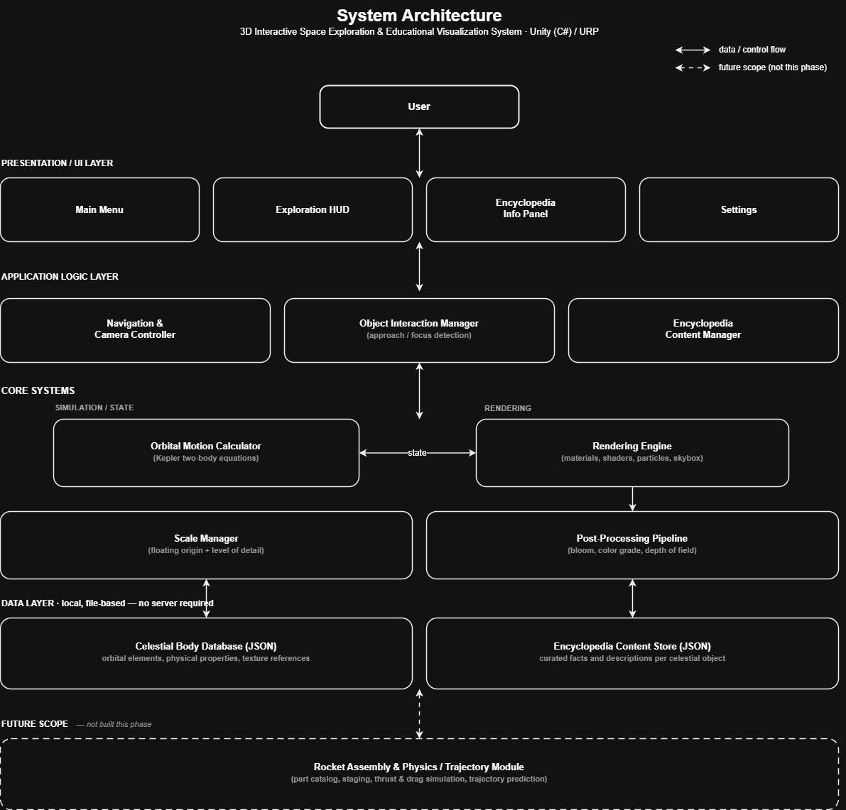

9. Functional Requirements
(i) The system shall render the Sun, eight planets, and a curated set of moons in a real-time 3D environment.
(ii) The system shall allow the user to freely navigate the 3D environment using standard free-roam camera controls.
(iii) The system shall update each celestial body's position over simulated time using two-body Keplerian orbital motion.
(iv)The system shall detect when the user's camera approaches a celestial object and trigger a focused view of that object.
(v) The system shall display curated encyclopedia-style content for a celestial object while the user is in its focused view.
(vi)The system shall render distant and nearby objects together without floating-point precision artifacts, via a floating-origin system.
(vii) The system shall render celestial bodies with increasing surface detail as the camera approaches, via a level-of-detail (LOD) system.
(viii) The system shall allow the user to exit a focused view and resume free-roam navigation at any time.
(ix) The system shall provide at least two curated deep-space destinations beyond the Solar System (e.g., a stylized black hole, a nebula).
(x) The system shall load celestial body and encyclopedia content from external data files (JSON) rather than hardcoded values, so new content can be added without code changes.

10. Non-Functional Requirements
(i) Usability: navigation controls should be learnable within a few minutes without requiring external instructions.
(ii) Performance: the application should maintain a stable real-time frame rate (target: 60 FPS) on standard demonstration/lab hardware.
(iii) Visual consistency: a consistent art direction and lighting approach should be applied across all rendered celestial bodies and environments, rather than mixed styles.
(iv) Scalability: the celestial body and encyclopedia data architecture should support adding new objects or content without modifying code.
(v) Reliability: the application should support continuous free-roam exploration sessions without crashes, memory leaks, or state corruption.
(vi) Portability: the current phase targets Windows desktop as the primary build platform; broader platform support is documented as future scope.

11. Methodology
- Requirement analysis and literature survey: completed as part of Project Proposal Part A; existing tools (Spaceflight Simulator, Spaceflight Simulator 2, Kerbal Space Program, Universe Sandbox, NASA's Eyes on the Solar System) reviewed and gaps identified.
- Environment and tooling setup: Unity project initialization, Universal Render Pipeline (URP) configuration, and installation of required packages (Shader Graph, Cinemachine).
- Data layer design — defining the JSON schema for celestial body properties (orbital elements, physical properties, texture references) and encyclopedia content entries.
- Core scene and navigation implementation: building the base 3D environment and the free-roam camera controller.
- Orbital motion and scale-management implementation : implementing the Kepler two-body position calculator and the floating-origin / level-of-detail system for astronomical-scale rendering.
- Rendering and shader development: implementing physically based materials, custom shaders (including Fresnel-based atmospheric rim-lighting), particle systems, and skybox/starfield rendering.
- Interaction and content system implementation: building the proximity/approach detection system, the focused-view camera transition, and the encyclopedia content display.
- Visual polish: applying the post-processing pipeline (bloom, color grading, depth of field), Cinemachine camera choreography, and UI animation.
- Integration, testing, and bug fixing: combining all modules into a single build and resolving integration issues.
- Documentation and final presentation preparation: finalizing the SDD, preparing the demo video, and preparing presentation materials.

12. Algorithms and Techniques
(i) Kepler two-body orbital mechanics (position from orbital elements as a function of time)
(ii) Floating-origin technique for large-scale coordinate precision
(iii) Level-of-detail (LOD) selection based on camera distance
(iv) Physically based rendering (PBR) : albedo / roughness / metallic material model
(v) Fresnel-effect shading (via Shader Graph) for atmospheric rim-lighting
(vi) Real-time shadow mapping
(vii) Particle system simulation for starfield and nebula effects
(viii) Camera interpolation and blending (Cinemachine) for smooth approach and transition behavior
(ix) Skybox / environment mapping for the background starfield
(x) Proximity and trigger-volume detection for the object-approach interaction system

13. Technology Stack
Component | Selected Tool
Programming Language | C#
Rendering Framework | Unity / Gadot
Image Processing | NA
Shader Authoring | Unity Shader Graph
Camera System | Cinemachine (Unity Package)
GUI | Unity UI Toolkit / UGUI
IDE | VS Code ( or other alternatives )
Version Control | GitHub

14. Dataset

Dataset /Asset | Source | Purpose
Orbital elements (semi-major axis, eccentricity, inclination, mean longitude, longitude of perihelion, longitude of ascending node) for all 8 planets | JPL Solar System Dynamics : Approximate Positions of the Planets (ssd.jpl.nasa.gov/planets/approx_pos.html) | Direct input to the two-body Kepler position calculator driving orbital motion
Physical data (radius, axial tilt, rotation period) | NASA science.nasa.gov planet pages (science.nasa.gov/mercury, /venus, /mars, etc. each has a "By the Numbers" facts section) | Planet scale, tilt, and rotation for rendering
Planet/moon texture maps (diffuse, normal, specular/roughness, cloud layer, Earth night-lights) | Solar System Scope (solarsystemscope.com/textures) | Primary, ready-to-use PBR-compatible planet textures
High-resolution planetary/lunar surface imagery (optional, higher fidelity) | NASA Visible Earth (visibleearth.nasa.gov) and USGS Astrogeology Science Center (astrogeology.usgs.gov) | Supplementary textures for higher visual fidelity, especially Earth, Moon, Mars
Mission and planetary photography (reference / encyclopedia visuals) | NASA JPL Photojournal (photojournal.jpl.nasa.gov) and NASA 3D Resources (nasa3d.arc.nasa.gov) | Reference imagery, supplementary 3D assets
Starfield / deep-space HDRI skyboxes | Poly Haven (polyhaven.com) | Background skybox and starfield rendering
Encyclopedia content (facts per celestial body) | Team-compiled from NASA and ISRO public sources, cross-checked against the Planetary Fact Sheet above | Curated educational content shown in the Encyclopedia Info Panel

15. Expected Deliverables
(i) Working Unity application (Windows desktop build) implementing the 3D space exploration and educational visualization system
(ii) Complete source code repository (GitHub), with commit and branch history reflecting actual development
(iii) Software Requirements Specification (SRS) and Software Design Document (SDD)
(iv)Test cases and a testing report
(v) Completed encyclopedia content set for all included celestial bodies
(vi)Presentation slides
(vii) Recorded demo video (as a backup for live demonstration)

16. Work Breakdown Structure
Below is the sample table. You can modify it as per the requirement of your project

Activity | Sampatti | Zels | Hriday
Literature Survey | ✔
Data Layer & Orbital Mechanics (Kepler calculator, JSON schema) | ✔ | ✔
Scale Manager (floating origin, LOD) | ✔ | ✔
Rendering & Shaders (PBR materials, Fresnel atmosphere shader, particles, post-processing) |  | ✔ | ✔
Camera System & Interaction (Cinemachine, approach/focus detection) |  | ✔ | ✔
Encyclopedia Content (research, writing, data entry) | ✔ |  | ✔
UI (menu, HUD, info panel) | ✔ | ✔ | ✔
Integration & Testing | ✔ | ✔ | ✔
Documentation (SRS/SDD) | ✔
Demo Video & Presentation | ✔ | ✔ | ✔

✔ - Due to current lack of detailed knowledge of the domain, the work breakdown for the technical steps are subject to change

17. Timeline (8–10 Weeks)
Below table gives you the idea about the work planning

Week | Activity
1 | Environment & tooling setup (Unity project, URP configuration, packages); finalize JSON schema for celestial body and encyclopedia data
2 | Core scene setup and free-roam camera navigation controller
3 | Orbital Motion Calculator (Kepler two-body); populate celestial body data — planets should be visibly orbiting by end of this week
4 | Scale Manager: floating-origin system and level-of-detail (LOD) implementation for astronomical-scale rendering
5 | Rendering Engine: PBR materials, Fresnel atmospheric rim-lighting shader, skybox/starfield
6 | Interaction Manager (approach/focus detection) and Encyclopedia Content Manager (system built, content not yet populated)
7 | Encyclopedia content population (real facts per body) and deep-space set-piece destinations (black hole, nebula)
8 | Visual polish: post-processing pipeline (bloom, color grading, depth of field), particle systems, Cinemachine camera choreography
9 | Integration, full playtesting, bug fixing, performance testing on actual demo hardware
10 | Demo video Recording and Final Presentation preparation

18. Innovation
New workflow Existing tools in this space split into two camps: scientifically rigorous but visually plain simulators (Spaceflight Simulator, Kerbal Space Program), and visually and scientifically strong but purely observational data browsers (NASA's Eyes on the Solar System). Neither is built around teaching at the moment of curiosity. The first two expect the user to already understand what they're building, and the third expects the user to already know what they're looking for.
This project's core innovation is a contextual, curiosity-triggered educational layer: information about a celestial object is surfaced automatically the moment the user approaches it, rather than requiring the user to consult an external wiki or a separate data panel. This is paired with:
- Scientifically accurate motion actually driving the visualization celestial bodies move along real Keplerian orbits rather than being placed statically for visual effect, which most purely artistic space visualizations skip.
- Production-value rendering techniques (physically based materials, custom atmospheric shaders, cinematic camera work) not commonly paired with scientific accuracy in existing educational tools, which tend to sacrifice one for the other.
- A data-driven, extensible architecture, allowing the system to grow into the originally scoped rocket-building and trajectory-simulation module as a later phase without a fundamental redesign

19. References

Documentation
(i) Unity Manual and Scripting API (https://docs.unity.com/en-us )
(ii) Unity Shader Graph documentation (https://docs.unity3d.com/Packages/com.unity.shadergraph@17.5/manual/index.html )
(iii) Unity Cinemachine documentation (https://docs.unity3d.com/Packages/com.unity.cinemachine@2.3/manual/index.html )
(iv) Unity Universal Render Pipeline (URP) documentation (https://docs.unity3d.com/6000.6/Documentation/Manual/urp/urp-introduction.html )

Research Papers
(v) Standish, E. M. -"Keplerian Elements for Approximate Positions of the Major Planets," JPL/Caltech technical note, available via JPL Solar System Dynamics (ssd.jpl.nasa.gov/planets/approx_pos.html ) - underlying formulation for the two-body Kepler position calculations used in this project

Data Sources
(vi) JPL Solar System Dynamics - Approximate Positions of the Planets (ssd.jpl.nasa.gov/planets/approx_pos.html) - orbital elements for Kepler two-body motion calculations
(vii) NASA Science - Solar System planet pages (science.nasa.gov/mercury, science.nasa.gov/venus, science.nasa.gov/earth, and equivalent pages for the remaining planets) - physical data (radius, axial tilt, rotation period) and encyclopedia content reference
(viii) NASA Visible Earth (visibleearth.nasa.gov) and USGS Astrogeology Science Center (astrogeology.usgs.gov) - high-resolution planetary and lunar surface imagery
(ix) NASA JPL Photojournal (photojournal.jpl.nasa.gov) and NASA 3D Resources (nasa3d.arc.nasa.gov) — reference imagery and supplementary 3D assets

Websites / Asset Sources
(x) Solar System Scope - solarsystemscope.com/textures - planet and moon texture maps
(xi) Poly Haven - polyhaven.com - starfield and deep-space HDRI skyboxes
(xii) NASA's Eyes on the Solar System - eyes.nasa.gov, science.nasa.gov/eyes
(xiii) Spaceflight Simulator - official game listings and developer information
(xiv) Spaceflight Simulator 2 - Team Curiosity development updates (teamcuriosity.com) and official Steam store page
(xv) Kerbal Space Program 2 - development status reporting, including its Wikipedia entry
(xvi) Universe Sandbox - official product information (universesandbox.com)
Suggested Standard References
(xvii) Bate, R. R., Mueller, D. D., & White, J. E. — Fundamentals of Astrodynamics, Dover

Publications
(xviii) Akenine-Möller, T., Haines, E., & Hoffman, N. — Real-Time Rendering, CRC Press

